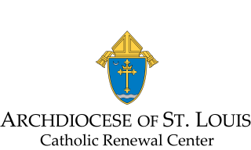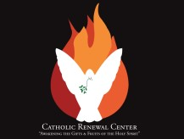

Application for Jonah Prayer Ministry Training Seminar
(For ministry only in the home parish)

Name __________________________________ Address _____________________________________

City/State _______________________________ Zip _________ Parish __________________________

Date _________________ Phone _________________________ e-mail __________________________

Check all that apply to you:
[ ] | I am able to observe and maintain total confidentiality of the prayer team.
[ ] | I can show compassion, love, kindness and fruits of the Spirit (Galatians 5:22).
[ ] | I will be united with the prayer team’s commitment to adhere to all the essential Catholic teachings and dogma on faith and morality including abortion.
[ ] | I will be able to give and receive ministry and function as part of the prayer team.
[ ] | I can follow the directives of others, be flexible, willing to learn and open to constructive criticism.
[ ] | I am open to the Holy Spirit by working with all the spiritual gifts given to prayer team members.
[ ] | I have a healthy lifestyle. That is, I have a good balance in my life physically, emotionally, psychologically, and spiritually.
[ ] | I know how and when to listen effectively.

Circle any of the following retreats you have attended: [ACTS, CHRP, Cursillo, White House, _______________________ ]

(Check all that apply)
[ ] I have attended 7 sessions of Life in the Spirit Seminars or the equivalent recently.
[ ] I have been prayed with for the Holy Spirit’s release in my life.
[ ] I have attended a Protecting God’s Children seminar through the St. Louis Archdiocese.
[ ] I have NOT attended a Protecting God’s Children seminar, but I am willing to do so.
[ ] I have attended a Prevent and Protect seminar through the St. Louis Archdiocese.
[ ] I have NOT attended a Prevent and Protect seminar, but I am willing to do so.

______________________________________________
(Signature of Pastor/Associate of your parish)

Recommended Reading:
The Practice of Healing Prayer –A How-To Guide for Catholics by Francis MacNutt

Send the completed, signed application to Catholic Renewal Center, 1406 S. Sappington Road, St. Louis, MO 63126 or email to catholicrenewal@archstl.org . You will receive further details and notifications of future JPM Seminars. For further questions call 314-731-6100.
